Early Years Learning in Mathematics community

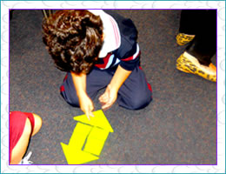
Professional Learning Resource
Naming shapes
Students take two squares of paper and fold them in half to make two triangles and two squares. The four pieces can be used like a jigsaw to make different shapes.
Enquiry
Can you make a square, or a rectangle?
What other quadrilaterals can you make?
A quadrilateral is a four-sided shape.
Can you make a hexagon?
What name might you name this shape in the photo?
Can you make a pattern that tessellates using more rectangles and squares?
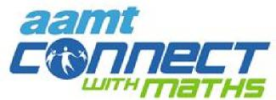 | Early Years Learning in Mathematics community

Teachers should know what students need to understand before and after this task. As part of the community other educators can make suggestions to similar tasks, pre-tasks and tasks that will scaffold students' understanding once they have developed this concept.
Especially, in the early years, mathematical tasks need to be hands on, often designed to develop understanding of the same concept. Effective teachers often repeat an activity in a similar way with different materials.
As other educators share ideas in this conversation or with other ideas, a specialised language teachers use to support numeracy with young children will also assist their’ pedagogical content knowledge.
This community can support the sharing of these ideas through conversations, sharing of ideas, resources, photos and descriptions of numeracy tasks.
Community shared resource – Sharyn Livy, Early Years Mathematics Specialist

